Instructor: Mr. Pranjul Sir

Course: Django Batch – 7 PM

Date: 21st Jan, 2023

Software Requirements Specification

*For*

Devhunt - A Creative Network

Version 1.0

Prepared by:

Ravi Kant

[Rvyknt@gmail.com](mailto:Rvyknt@gmail.com)

8860733786

**Introduction**

**Purpose**

It will provide a platform for user and developers to connect with each other and resolve their queries. It can be communication tool for efficient exchange of ideas and opportunities. With this platform user can advertise their work and contact developers for work all form the comfort of their home.

**Document Conventions**

This document uses Times New Roman font throughout the entire document. Major header lines use bold, size 24 font. Subsections use bold, size 20 font.

Smaller subsections use bold, size 16 font. Any part of this document that is not a header of some kind uses size 14 font. The one-inch margins are maintained throughout this document as well.

**Intended Audience and Reading Suggestions**

This document is intended for faculty and teaching assistants of our team, and anyone else interested in learning more about the Devhunt Platform. The remainder of this document provides the general product description and a technical outline for the requirements of this system.

**Project Scope**

Easily display their work for world to see and appreciate. User can contact each other regarding projects, work and opportunities as developer and visitor. Essentially it is a social media platform for developers. Inspire and boost creativity among dev community.

**References & Acknowledgement**

• Django official documentation

• SQLite: Inbuilt in Django.

• Python official documentation

• Stack Overflow

**Dependencies:**

* asgiref==3.3.4
* autopep8==1.5.7
* boto3==1.18.0
* botocore==1.21.0
* Django==3.2.4
* django-cors-headers==3.7.0
* django-storages==1.11.1
* djangorestframework==3.12.4
* djangorestframework-simplejwt==4.7.2
* gunicorn==20.1.0
* jmespath==0.10.0
* Pillow==8.2.0
* psycopg2==2.9.1
* pycodestyle==2.7.0
* PyJWT==2.1.0
* python-dateutil==2.8.2
* pytz==2021.1
* s3transfer==0.5.0
* six==1.16.0
* sqlparse==0.4.1
* toml==0.10.2
* urllib3==1.26.6
* whitenoise==5.2.0

**Over Description**

**Product functionality**

The user can sign up with details he/she required.

* Email
* Password

Additional details required for better experience:

* Name
* Bio
* Short intro
* Skill
* Social links
* Location

The admin can sign up with

* Email
* Password

On login, user and admin will be required to enter following credentials:

* Email
* Password

**At User Side**

A user or visitor have access to these:

* Send message
* See Developer profile
* See project page
* Sign in
* Registration

**At logged In User Side:**

A registered have access to these:

* Send messages
* Review
* Profile details
* Project
* Skill

**At admin side:**

Admin have access to these:

* User
* Projects
* Reviews
* Tags
* Messages
* Profiles
* skills

**Flowchart**

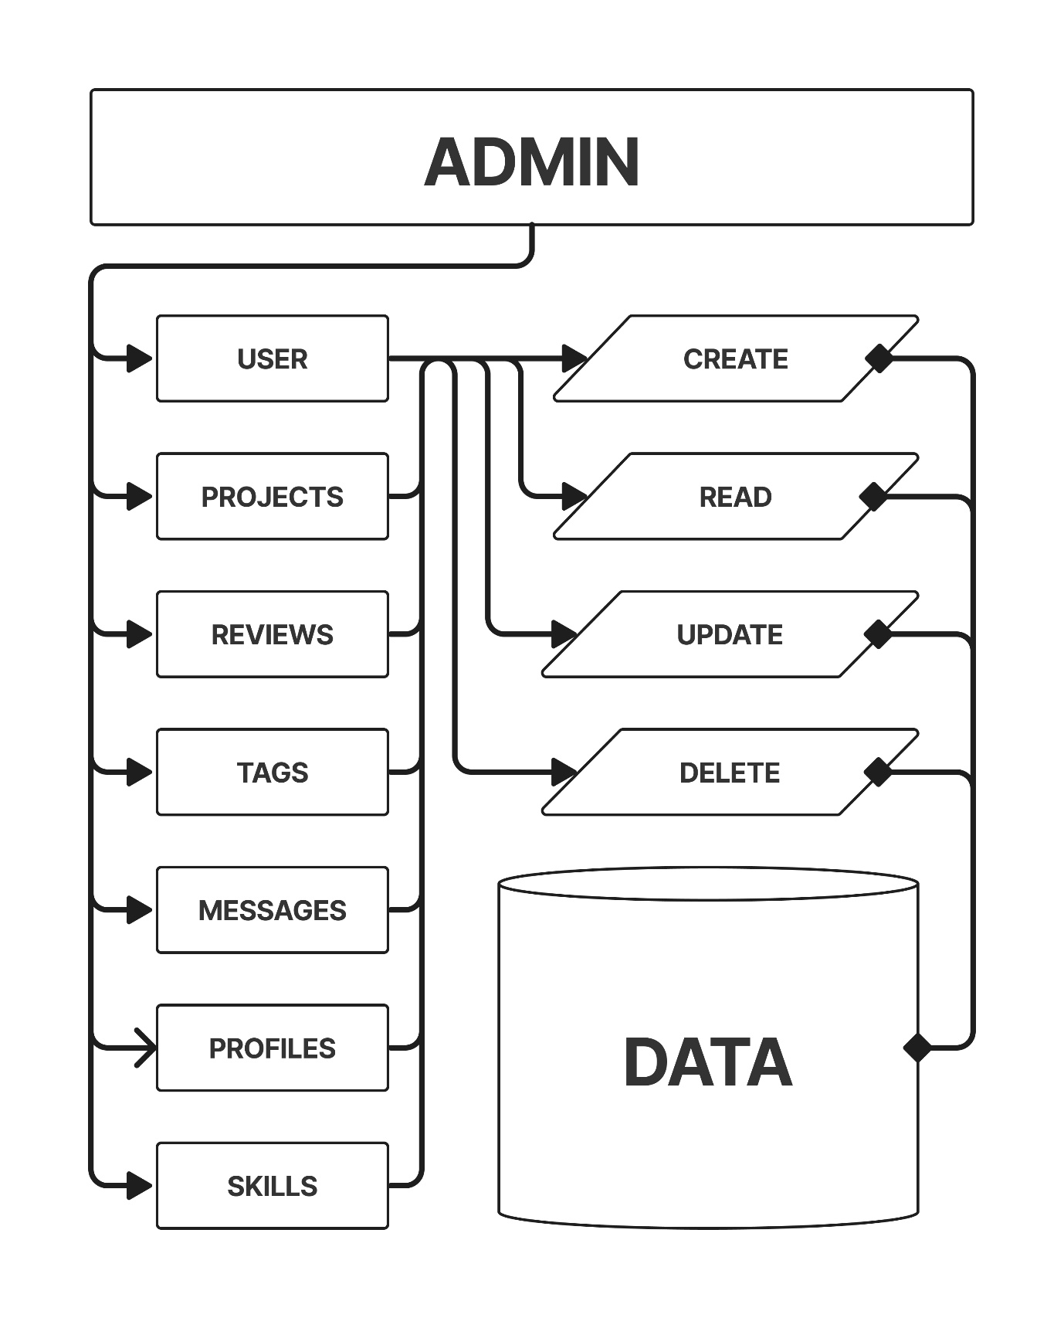

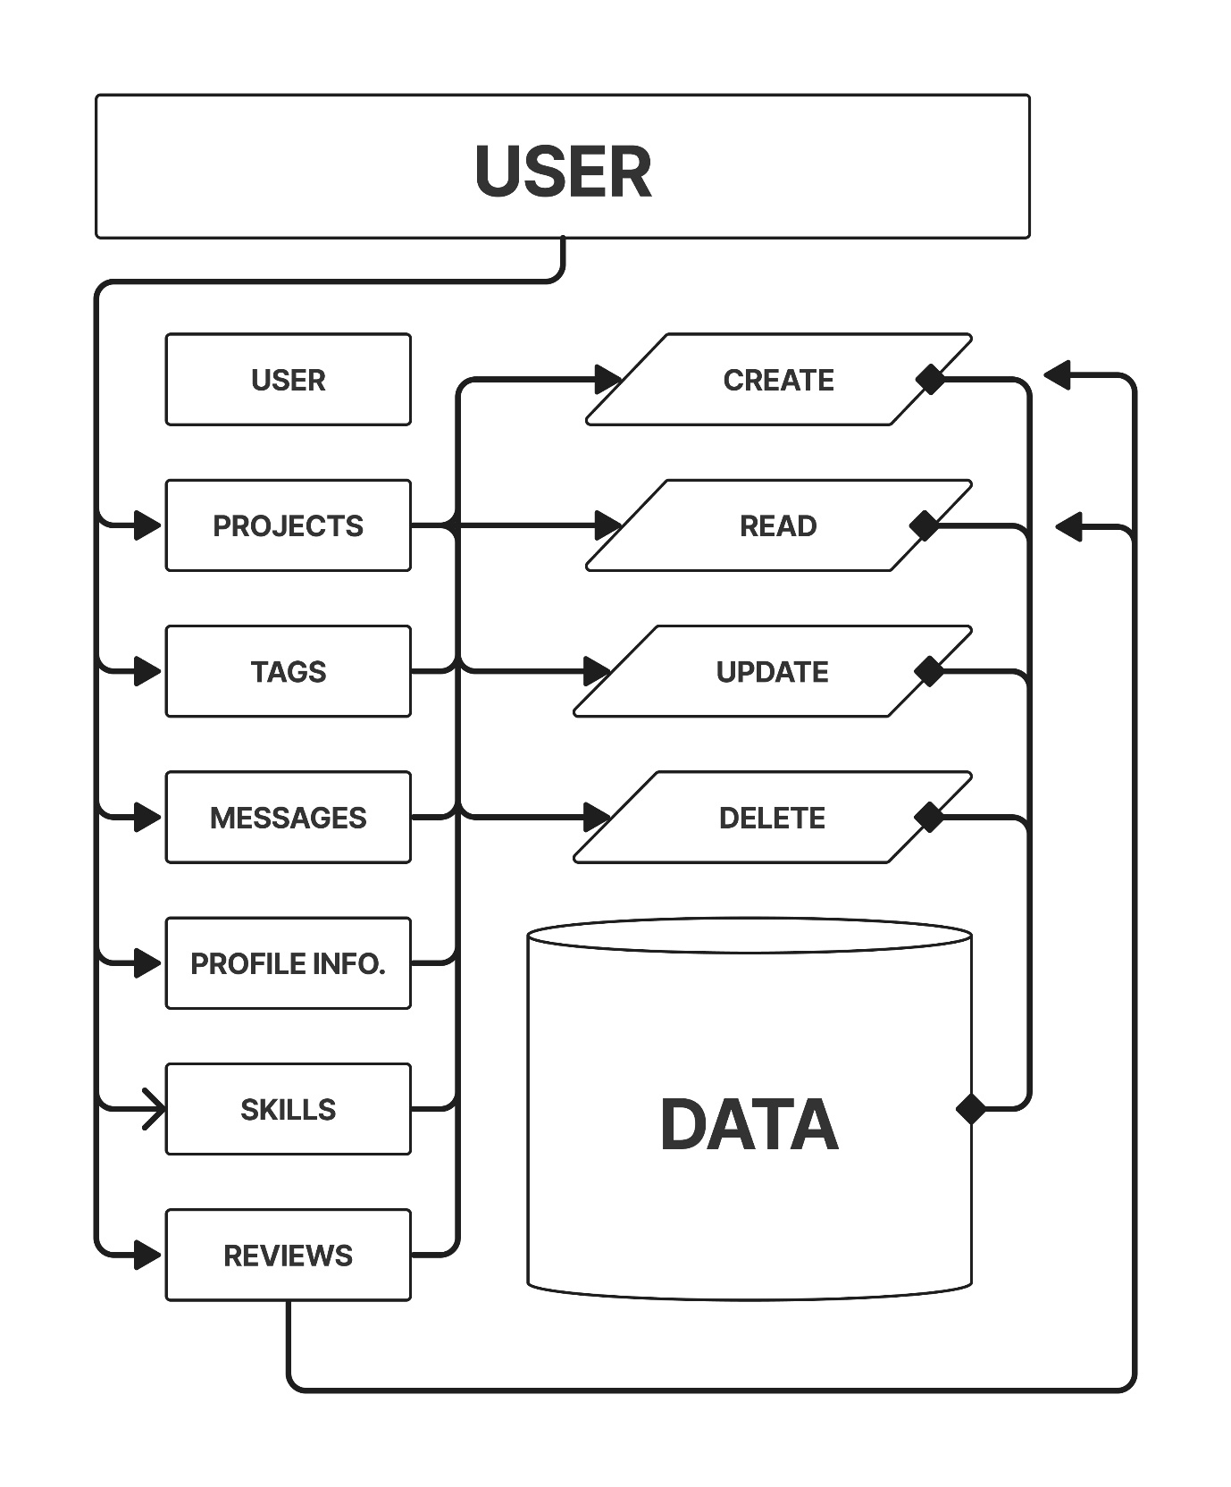

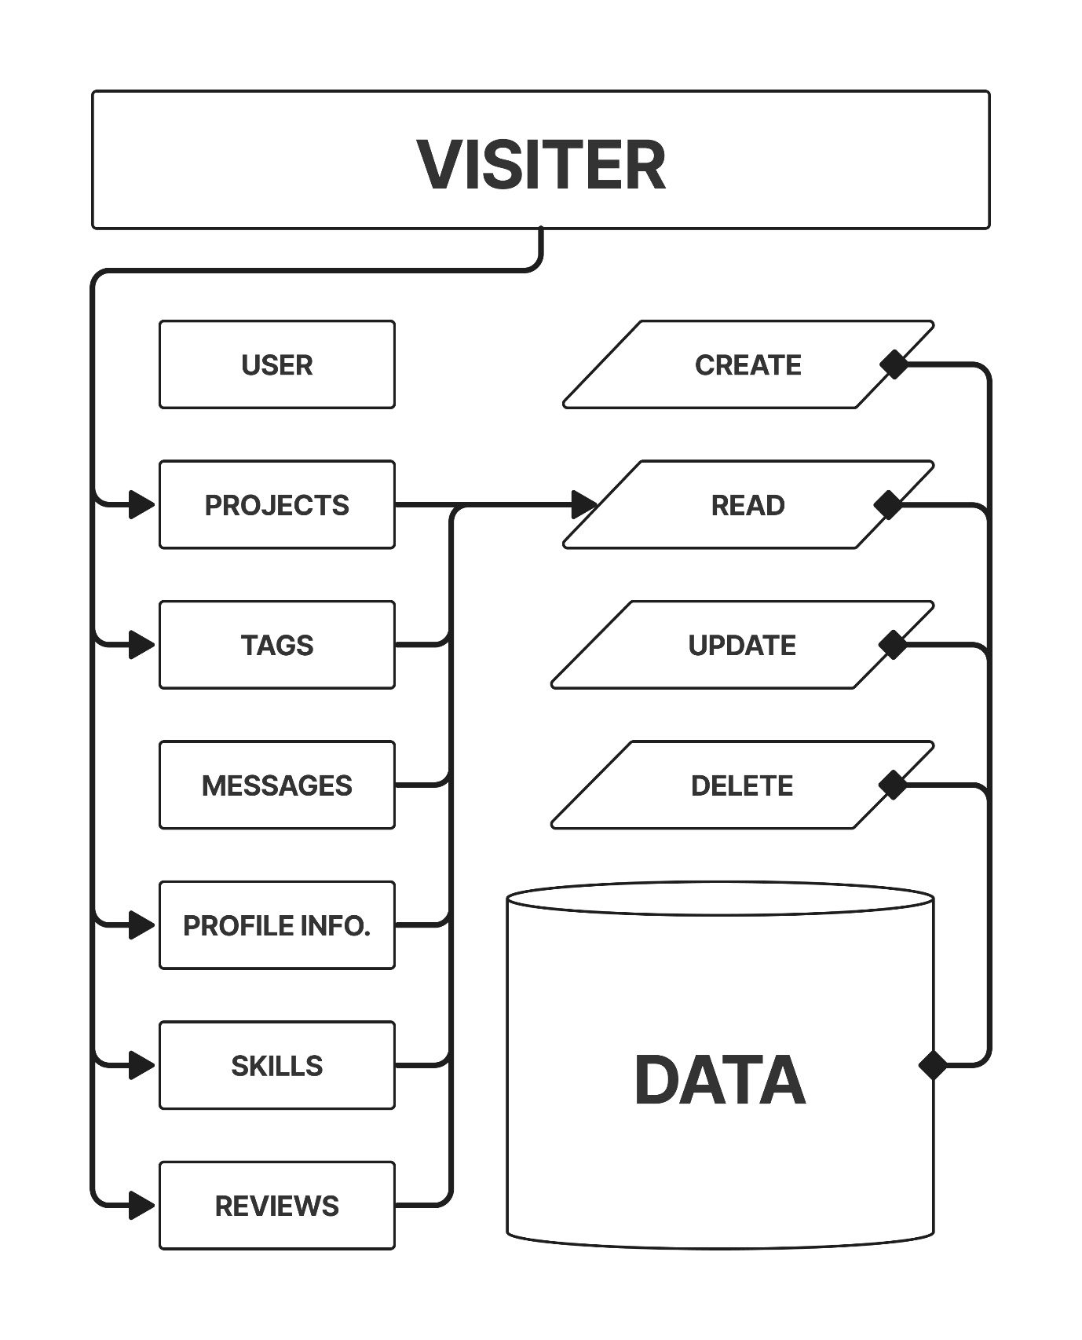

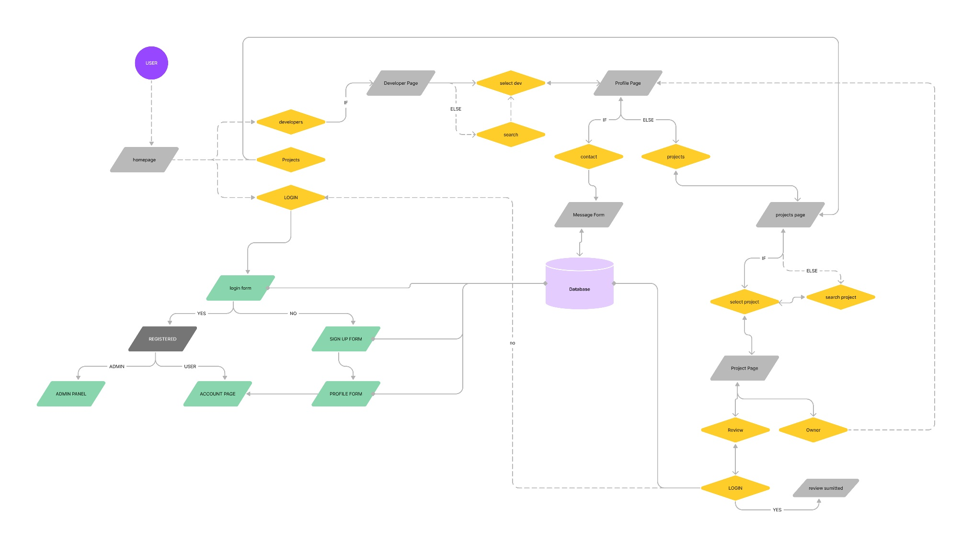**ER Diagram**